phpStageManager documentation

Table of Contents

Introduction 1

Installation 1

Prerequisites 1

Setup 2

Getting started 2

Home 2

Signing in 2

Calendar 3

Viewing events 3

Viewing your custom calendar 4

Subscribing to the calendar 4

Creating new events 4

Directory 5

Editing the directory 5

Editing your own directory information 5

Scene Breakdown 5

# Introduction

Welcome to phpStageManager! phpStageManager (PSM) is a web-based theatre management utility. It allows you to simplify the management of your theatre production by handling your calendar, scene breakdown, and company contact information. It automatically allows actors to easily see a customized schedule with only their rehearsals.

# Installation

## Prerequisites

To use phpStageManager, you will need:

* A web server (PSM is only tested with Apache, but any web server should work)
* PHP 5.x
* php_mysql extension
* MySQL server

## Setup

To install phpStageManager, follow these steps:

1. Copy all files from the master branch of PSM git repository (github.com/oxguy3/phpStageManager) into a directory serviced by your web server.
2. Create a database on your MySQL server for PSM (you can name it whatever you like, but the default option in the sample config file is "phpstagemanager") and execute install.sql on this database (using MySQL Workbench, phpMyAdmin, or other means).
3. Open psm_config-sample.php and edit all the variables to suit your particular server setup (descriptions for the variables are included in the file). When you are finished, save the file as psm_config.php.
4. In a web browser, go to the address where PSM is located on your web server (this will likely require that your web server be configured to recognize "index.php" as a directory index file).
5. In the login box at the top left, log in with the username "admin" and whatever password you want (the password you enter will be saved as the admin password). You should now be all set!
6. (Optional) If you wish to make your PSM installation entirely inaccessible without a password, you may configure your web server to require HTTP authentication for PSM's directory

# Getting started

Now that you have successfully installed phpStageManager, it's time to get acquainted with it.

## Home

The home page is actually included from another website; in a typical configuration, it is imported from a Google Drive document, a link to which is included at the bottom of the page. Thus, to edit the home page announcements, simply click the link to the Google Doc at the bottom of the home page and edit it directly on Google Drive.

## Logging in



While it is possible to view most sections of the website without needing to log in, you will need to sign in as an administrator to edit the calendar, directory, or scene breakdown. By default, PSM comes with an administrative account. By using the Username and Password fields in the top left corner of the website, you can sign into this account with the username "admin" and whatever password you choose (the password you use the first time you login as "admin" will be saved as the permanent password for the account). Once other users have been created, they can also log in using this form.

# Calendar

The most essential function of phpStageManager is, of course, the calendar. You can access it by clicking the Calendar tab on the navigation bar.

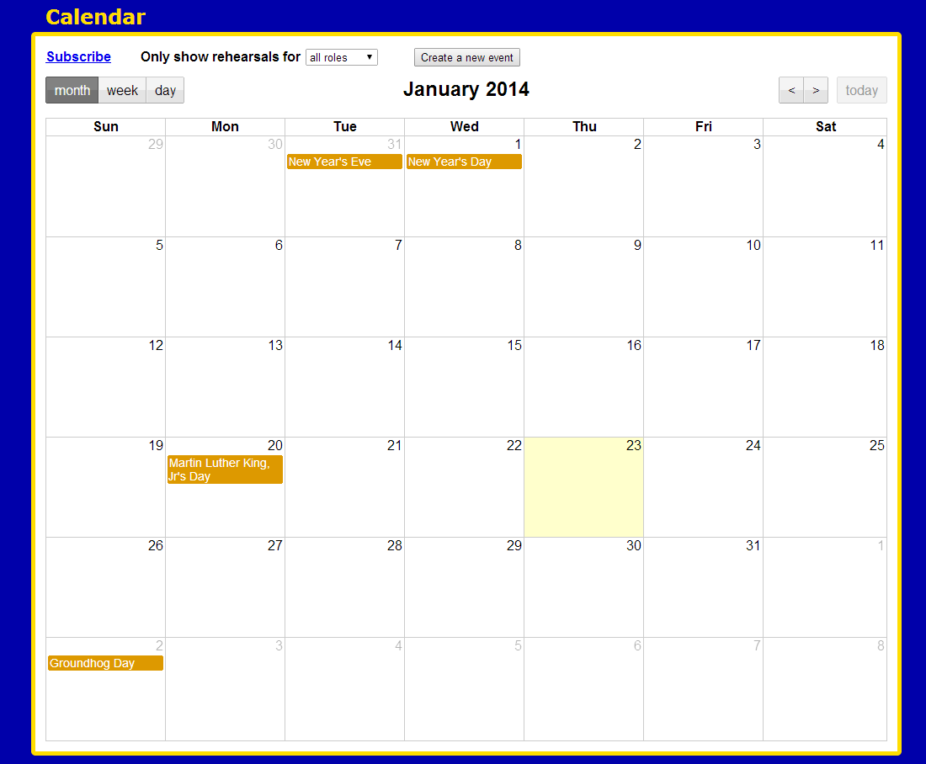

## Viewing events

Events on the calendar will show up in orange, green, blue, and red. Orange events are holidays imported from a special Google Calendar of national holidays; you can click on these for more information. Events of any other color are events from PSM's own calendar. The color represents the status of the event:

* green = confirmed
* blue = tentative
* red = canceled

To view details of an event, you can hover your mouse over it for quick information, or click on it for full details (on mobile devices, the quick information is not available). If you are signed in as a power user or administrator, clicking an event will also allow you to edit its details or delete it.

To find events, you can use the "<" and ">" buttons at the top right to move back in forth in time, and the "month", "week" , and "day" buttons at the top left to change the perspective of the calendar.

## Viewing your custom calendar

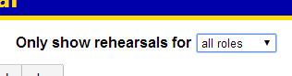

The calendar offers many options to precisely choose what types of events should be shown. At the top, click the dropdown menu labeled "Only show rehearsals for". This dropdown allows you to specify which events should be shown. You can choose "all roles" to show all rehearsals, or choose a particular person or role to view only the rehearsals to which that person/role is called.

## Subscribing to the calendar

PSM includes an iCalendar feed for its calendar, allowing many scheduling apps (such as iCal, Outlook, or iOS' built-in calendar) to subscribe to PSM's events. Simply open your calendar of choice (see "Viewing your custom calendar" above) and click the "Subscribe" button. Your calendar app should automatically detect this and provide you options to subscribe to the feed.

If your calendar app is not detecting when you click the "Subscribe" link, you can copy the link address of the "Subscribe" link and paste it into your calendar app manually. You should also verify that your calendar app is compatible with the iCalendar format.

## Creating new events

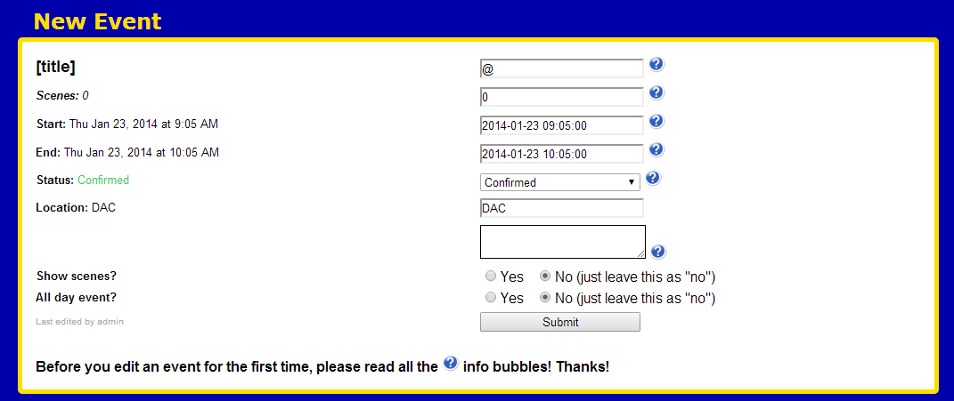

To create a new event on the calendar, you can either click the "Create a new event" button at the top, or click on the day and time on the calendar when you want the event to occur. Either way, you will end up at a form which will allow you to fill in all the details. For explanations of each field of the event page, hover your mouse over the blue question mark icons.

# Directory

The directory is where the contact information for everyone in your company can be found. It can be accessed by the Directory button on the navigation bar. The directory sorts the company alphabetically by last name and shows their name, roles, phone numbers, and email addresses.

## Editing your own information

To edit your own information that appears in the directory, you will need to log in to the website using the form at top right corner of the website. If you do not know your username and password, it is most likely to be the username and password issued to you by your school/organization.



Once you have logged in, click the Settings button in the top right corner of the website. You will then be able to edit your phone numbers and email address. If you need to change other information of yours, contact an administrator.

## Editing others' information

If you are logged in as an administrator, there will be a pencil icon next to each name in the directory. Click the pencil icon to open a form to edit the details of that user. Change the fields to the desired fields and save it to edit the user's details.

## Adding new people

New company members can be added to the directory from the Administrative Control Panel; see the relevant section for details.

# Scene Breakdown

The scene breakdown shows exactly which roles are involved in which scenes. This page can be accessed via the Scenes tab on the navigation bar.

The roles are sorted in alphabetical order in the first column on the scene breakdown, and every column thereafter represents each scene in the show. Every X represents a scene that that role appears in.

## Editing the scenes

If you are logged in as an administrator, you can edit the roles listed in the scene breakdown. Next to each role in the breakdown is a pencil icon. Click the pencil icon, and you will be able to modify what scenes that role is attached to.

## Adding new roles

To add new roles to the scene breakdown, click the add button. You will be taken to a form where you can specify the name of the role and the scenes it appears in. When you have finished listing the scenes, save the form, and the role will be added to the scene breakdown.

## Changing the number of scenes

The scene count can be changed in the Administrative Control Panel; see the relevant section for details.

# Administrative Control Panel

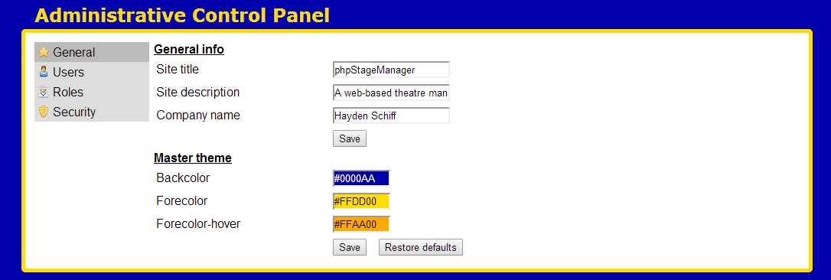The administrative control panel is a page that can be used to modify the global settings of the website. To access it, log in to the website as an administrator. The admin panel is split into multiple sections which can each be accessed with the links on the grey bar to the left.

## General

The "General" section of the admin panel allows you to change basic properties of PSM such as the website title and description, as well as the color palette of the website. The color palette can be chosen either by entering hexadecimal color codes, or by using the color picker that appears upon clicking the color text boxes.

## Users

The "Users" section allows you to add new people to the website by filling out a form with their information. By default, when you create a new user with this form, it will create an account for them with no password set. If your installation of PSM is configured to authenticate with a mail server, then the user will be required to log in with their school/organization issued password the first time they log in. Otherwise, their password will simply be set to whatever they enter as their password the first time they try to log in.

## Roles

The "Roles" section allows you to add new roles to the show, as well as to change the number of scenes in the show.